**How to Improve the Design of My Learning Space**

From the report” Dynamic lighting system for the learning environment: performance of elementary students (following abbreviate as ‘the report’)” by Kyungah Choi and Hyeon-Jeong Suk, the design of learning space has a significant impact on the quality of learning, Therefore, I am writing this report to analyse how to improve the design of my learning space.

My learning space is like Picture 1: When open the door, you will see my crowdy table arranging various things; on the right side is a bookshelf, and in front of it is a cabinet; on the left is a bed; the window is on the far-left side of the bed but staggered with the desk for a distance.

Picture 1

From the report, we know that it has the following problems:

1. Window position. Because it is far, natural light can not illuminate the table directly. Consequently, I must turn on the indoor light or table lamp to improve the light level inside.
2. The temperature of the light. From the report, we know that temperature around 6500K could be best for learning. However, the light in my room is a common light with wight colour which almost around 4500K.
3. Crowded. The small table with big amount things upper. It is hard for me to writing and put all the materials on.

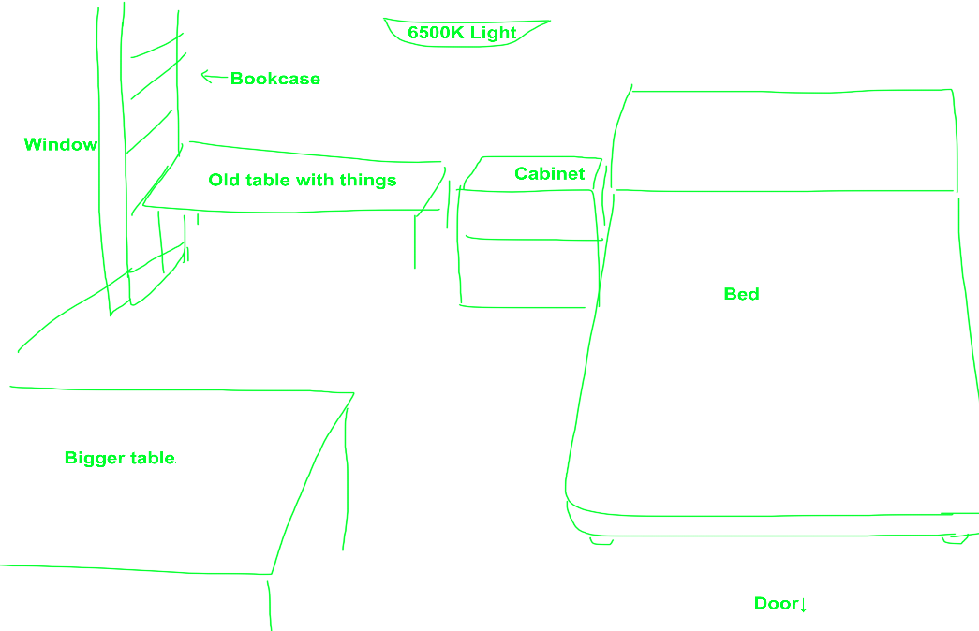Solutions to improve: First, the table is moved near to the window so that the natural light can illuminate directly. Second, indoor light is changed to a 6500K light temperature version. Third, table is changed to a bigger version, and the replaced table can be used to place things on. The final design is like Picture 2.

Picture 2